**Flutter installation on Windows**

**System requirements:**

To install and run Flutter, your development environment must meet these minimum requirements:

* **Operating Systems**: Windows 10 or later (64-bit), x86-64 based.
* **Disk Space**: 2.5 GB (does not include disk space for IDE/tools).
* **Tools**: Flutter depends on these tools being available in your environment.
  + [Windows PowerShell 5.0](https://docs.microsoft.com/en-us/powershell/scripting/install/installing-windows-powershell) or newer (this is pre-installed with Windows 10)
  + [Git for Windows](https://git-scm.com/download/win) 2.x, with the **Use Git from the Windows Command Prompt** option.

If Git for Windows is already installed, make sure you can run git commands from the command prompt or PowerShell.

**Get the Flutter SDK**

1. Download the following installation bundle to get the latest stable release of the Flutter SDK:

[**Download link**](https://docs.flutter.dev/release/archive?tab=windows)

1. Extract the zip file and place the contained flutter in the desired installation location for the Flutter SDK. I extract the zip at **C:\Flutter**

**Warning**: Do not install Flutter to a path that contains special characters or spaces.

**Warning**: Do not install Flutter in a directory like C:\Program Files\ that requires elevated privileges.

**Update your path**

1. Next, you need to update your Path environment variable to run Flutter commands in Windows consoles PowerShell and Command Prompt (CMD). First, click the Start button and “env” and then click on **Edit environment variables for your account**.

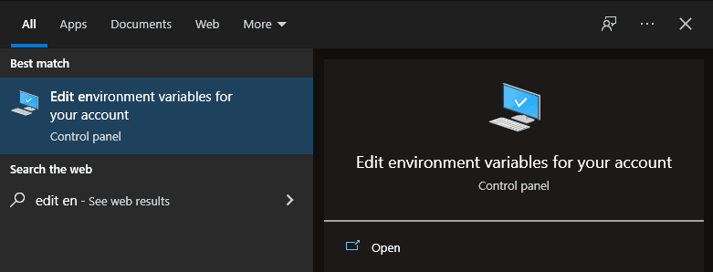

1. Under User variables, click on and highlight **Path**. Click **Edit**.

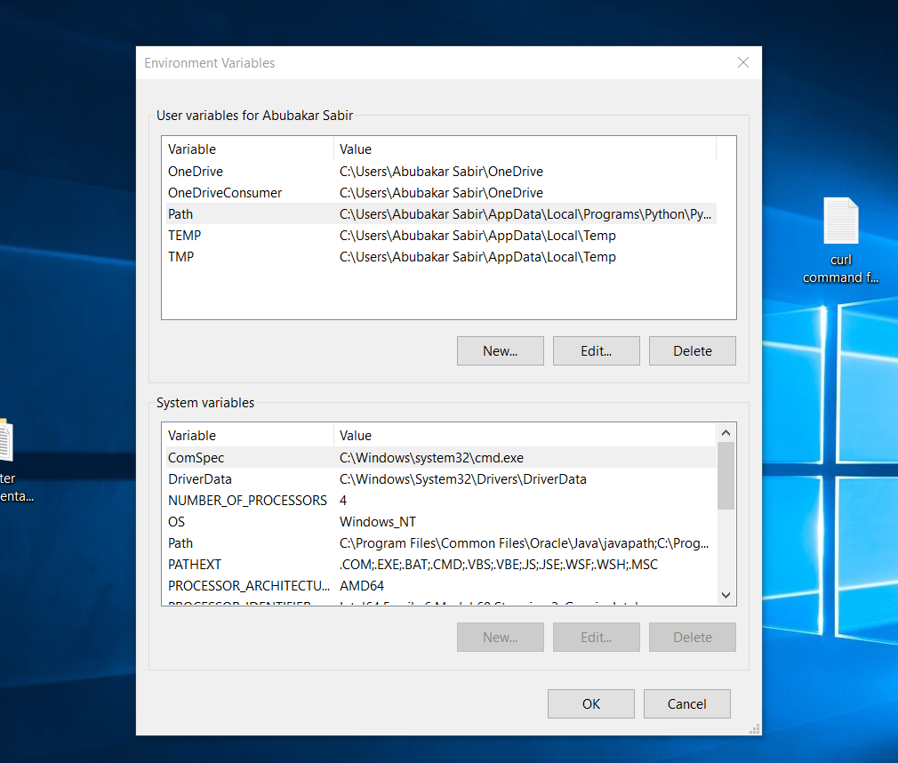

1. On the next screen, click **New**and add the full path to your *flutter\bin* directory. For this guide, it is shown below. Click OK on both windows to enable running Flutter commands in Windows consoles.

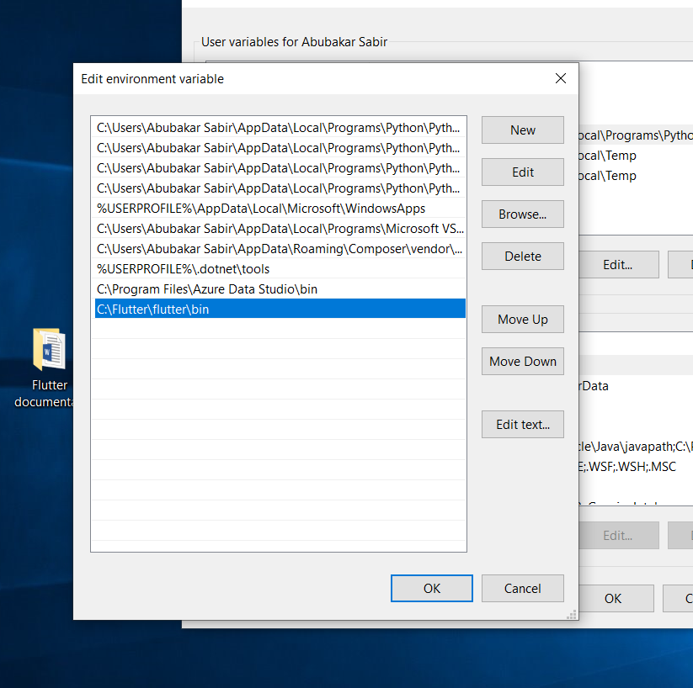

**Confirm Installed Tools for Running Flutter**

In CMD, run the *flutter doctor*command to confirm the installed tools along with brief descriptions.

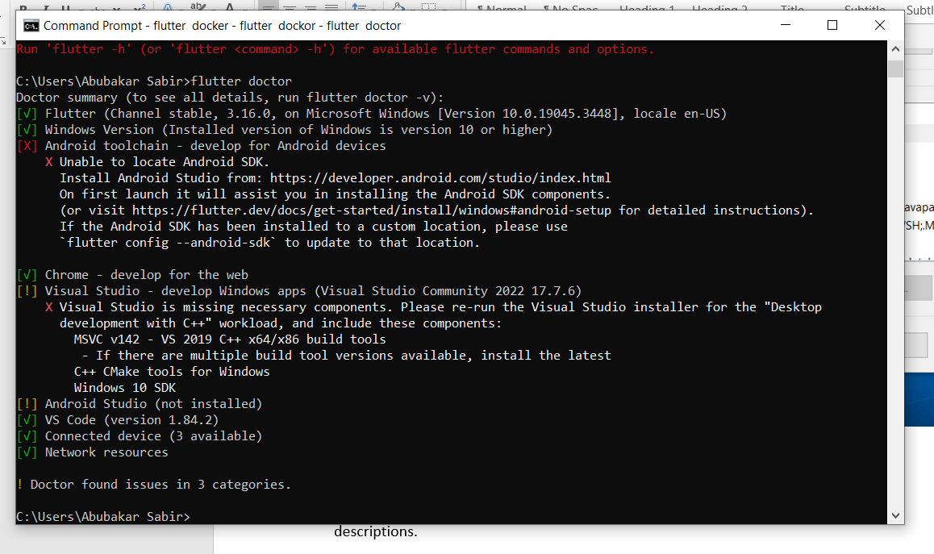

As visible, several components still need to be installed to complete the installation.

**Install VS code and run Android Emulator with VS code.**

For installing the VS code along with Android emulator for flutter development watch the given video. Remember you must have enough free space in your C drive or where you want to set up Android Studio and it’s emulator(minimum 20GB).  
[How To Run Flutter App in VSCode Android Emulator on Windows 10 or 11 (2023)](https://www.youtube.com/watch?v=EhGW4UYpKSE)

**Now Install VS code**

There are two options. You can install VS code or Android Studio. I am using VS code because I already have it and it is lightweight.

**If you want to install and setup Android Studio then see this** [**documentation.**](https://www.liquidweb.com/kb/how-to-install-and-configure-flutter-sdk-windows-10/)

Download the user installer of VS code from [here](https://code.visualstudio.com/download) and simply install it. Once you install the VS code then follow these bellow steps.

1. Installing Flutter extension in Visual Studio Code

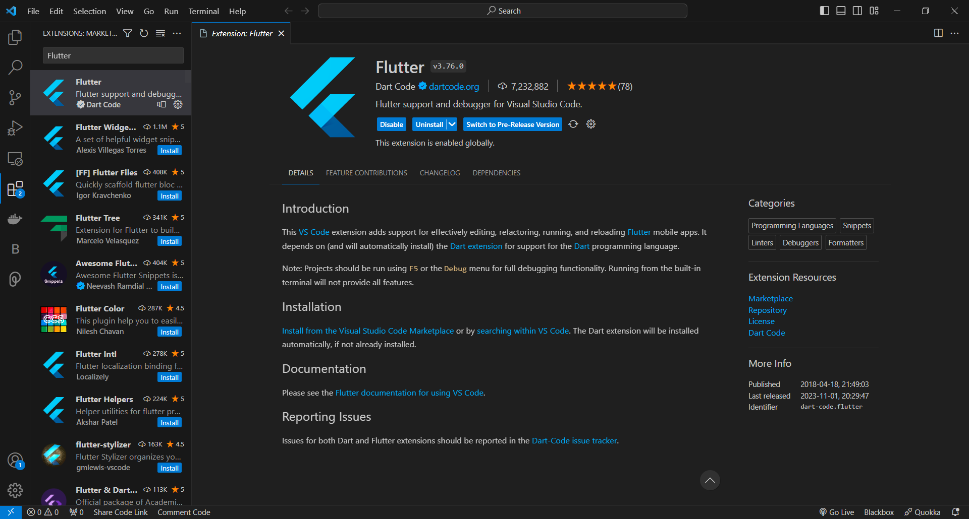

1. Now install Dart in Visual Studio Code

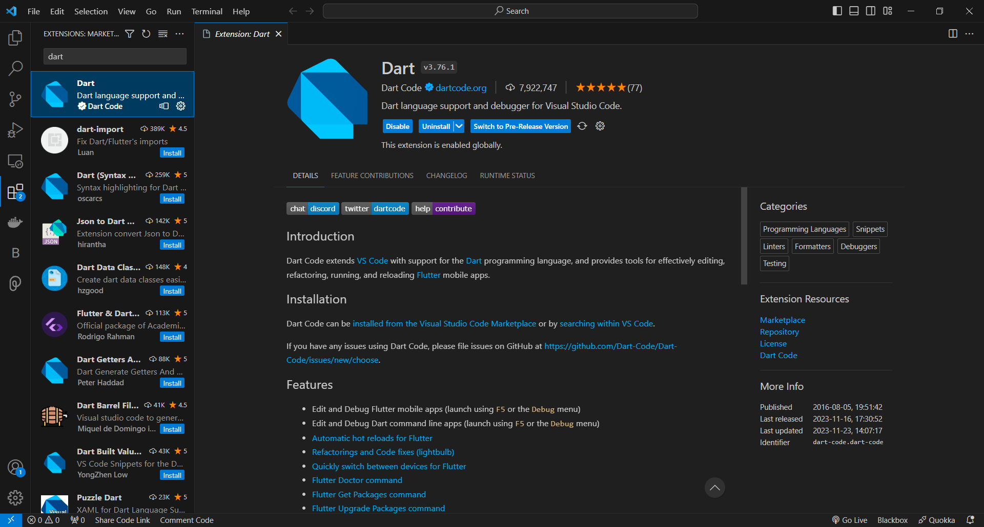

1. Now we have successfully added Flutter and Dart to the Visual studio code, now let’s check if flutter is installed or not. For this we will open a new terminal in Visual Studio Code (**Terminal > New Terminal**) and type the following “**flutter --version”,**if everything is fine then it will normally show the version of the installed flutter.

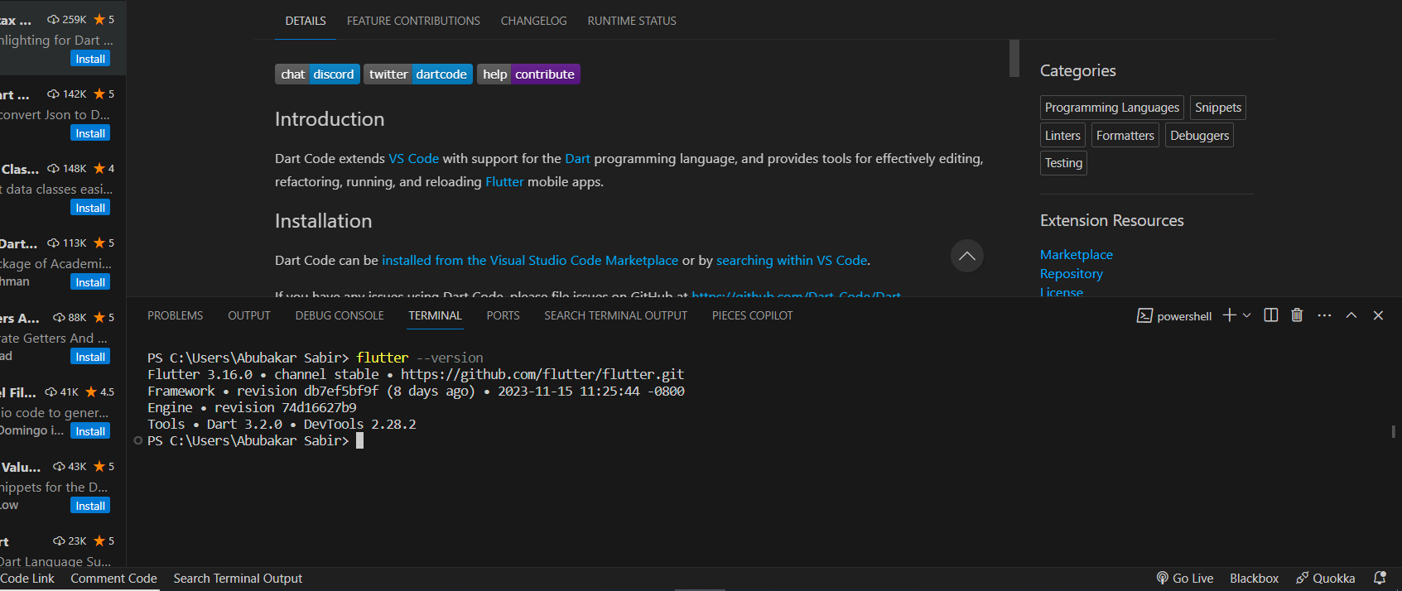

1. Now we are ready to create a new flutter project, for that we have to select a directory in which we are going to create the project. Click on the green button of the Open folder and then choose a preferred location.

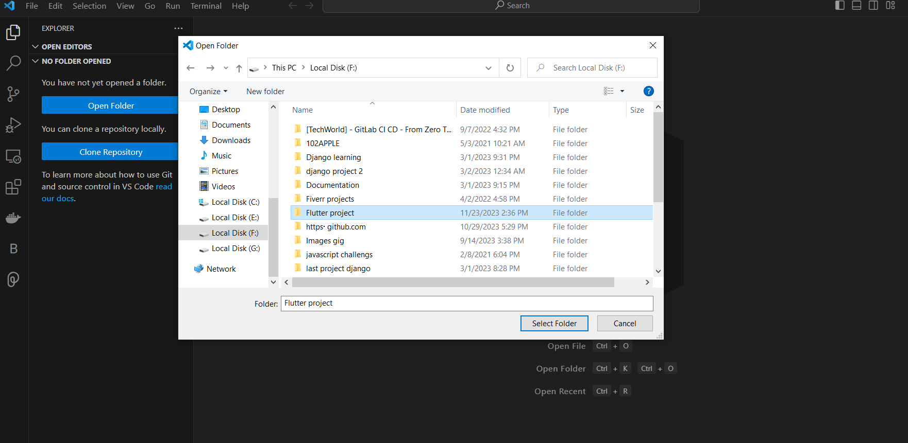

1. Creating a new project

* Go to **View** > **Command Palette…**.

You can also press Ctrl / Cmd + Shift + P.

* Type flutter.
* Select the **Flutter: New Project**.
* Press Enter.
* Select **Application**.
* Press Enter.
* Select a **Project location**.
* Enter your desired **Project name**.

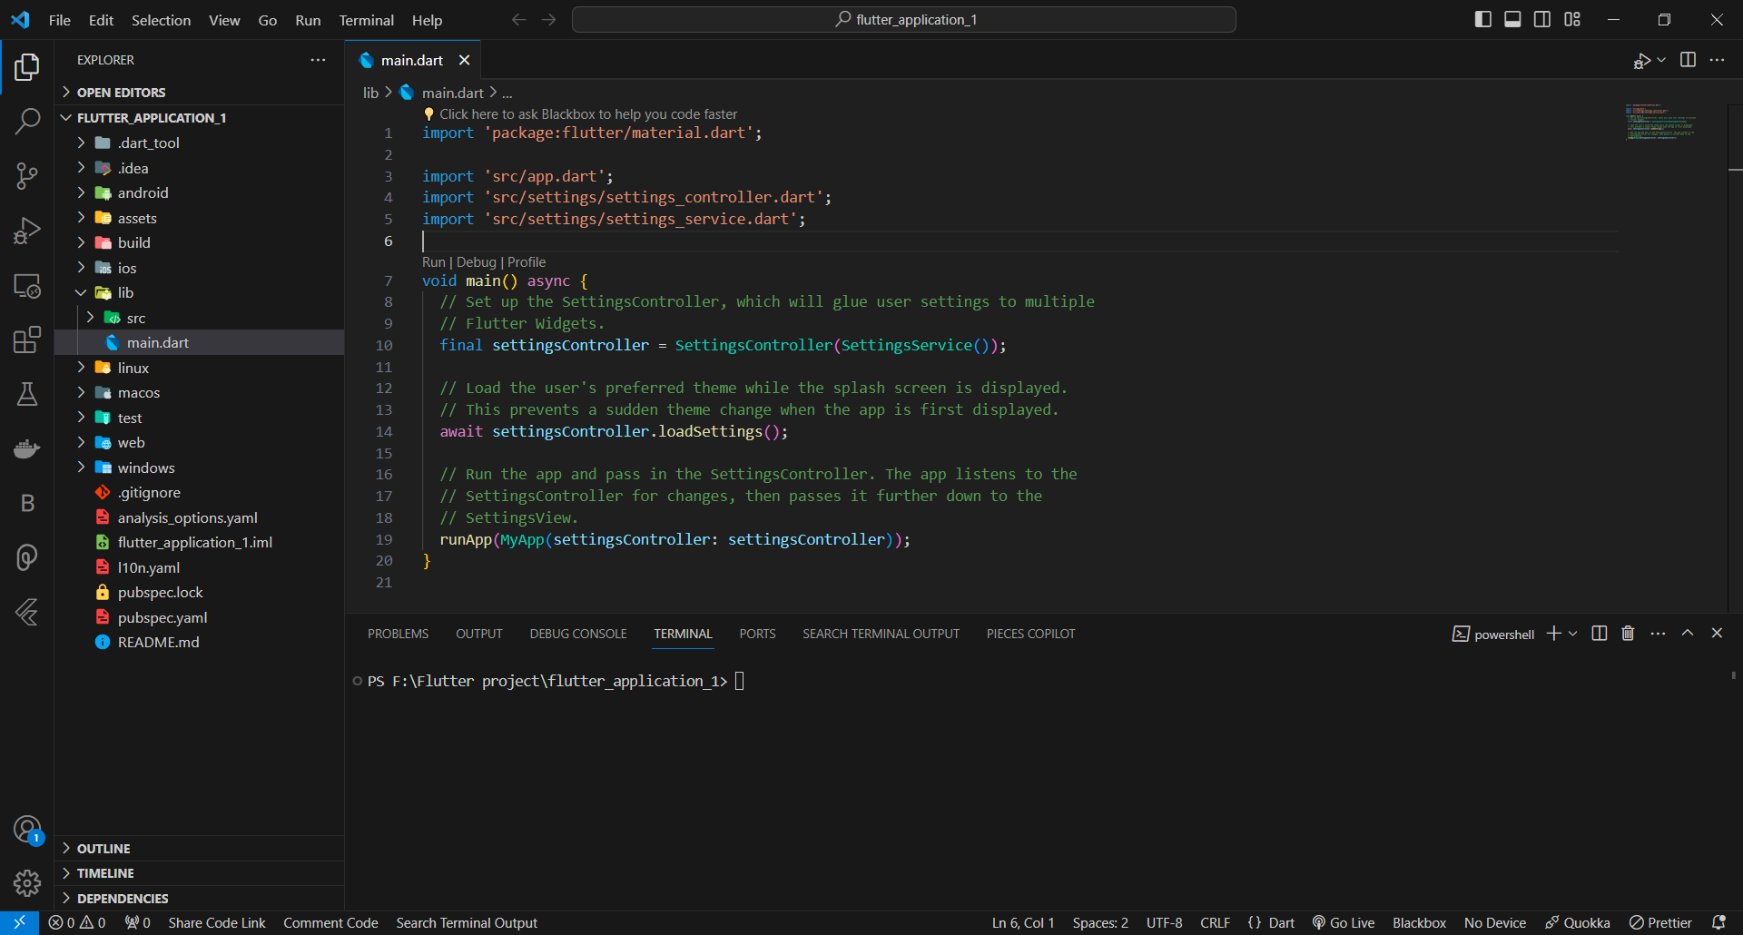

Flutter project is created now we have to run this program in order to check that if it is working or not. Here we need to understand that how a flutter project will show the output. We can run a flutter program in android emulator or we can run this in our browser as well. For running in the android emulator, we must have the android studio installed in our system. For this article, we are going to test this program in our browser.

1. Running Flutter project

For running the Flutter project go inside the project that you created if you are not inside the directory. For this porous run this command **cd flutter_application_1** (replace flutter_application_1 with your project name). Now run **flutter run** command. It will ask where would you like to see the output, now choose for the desired browser by typing 1 or 2.

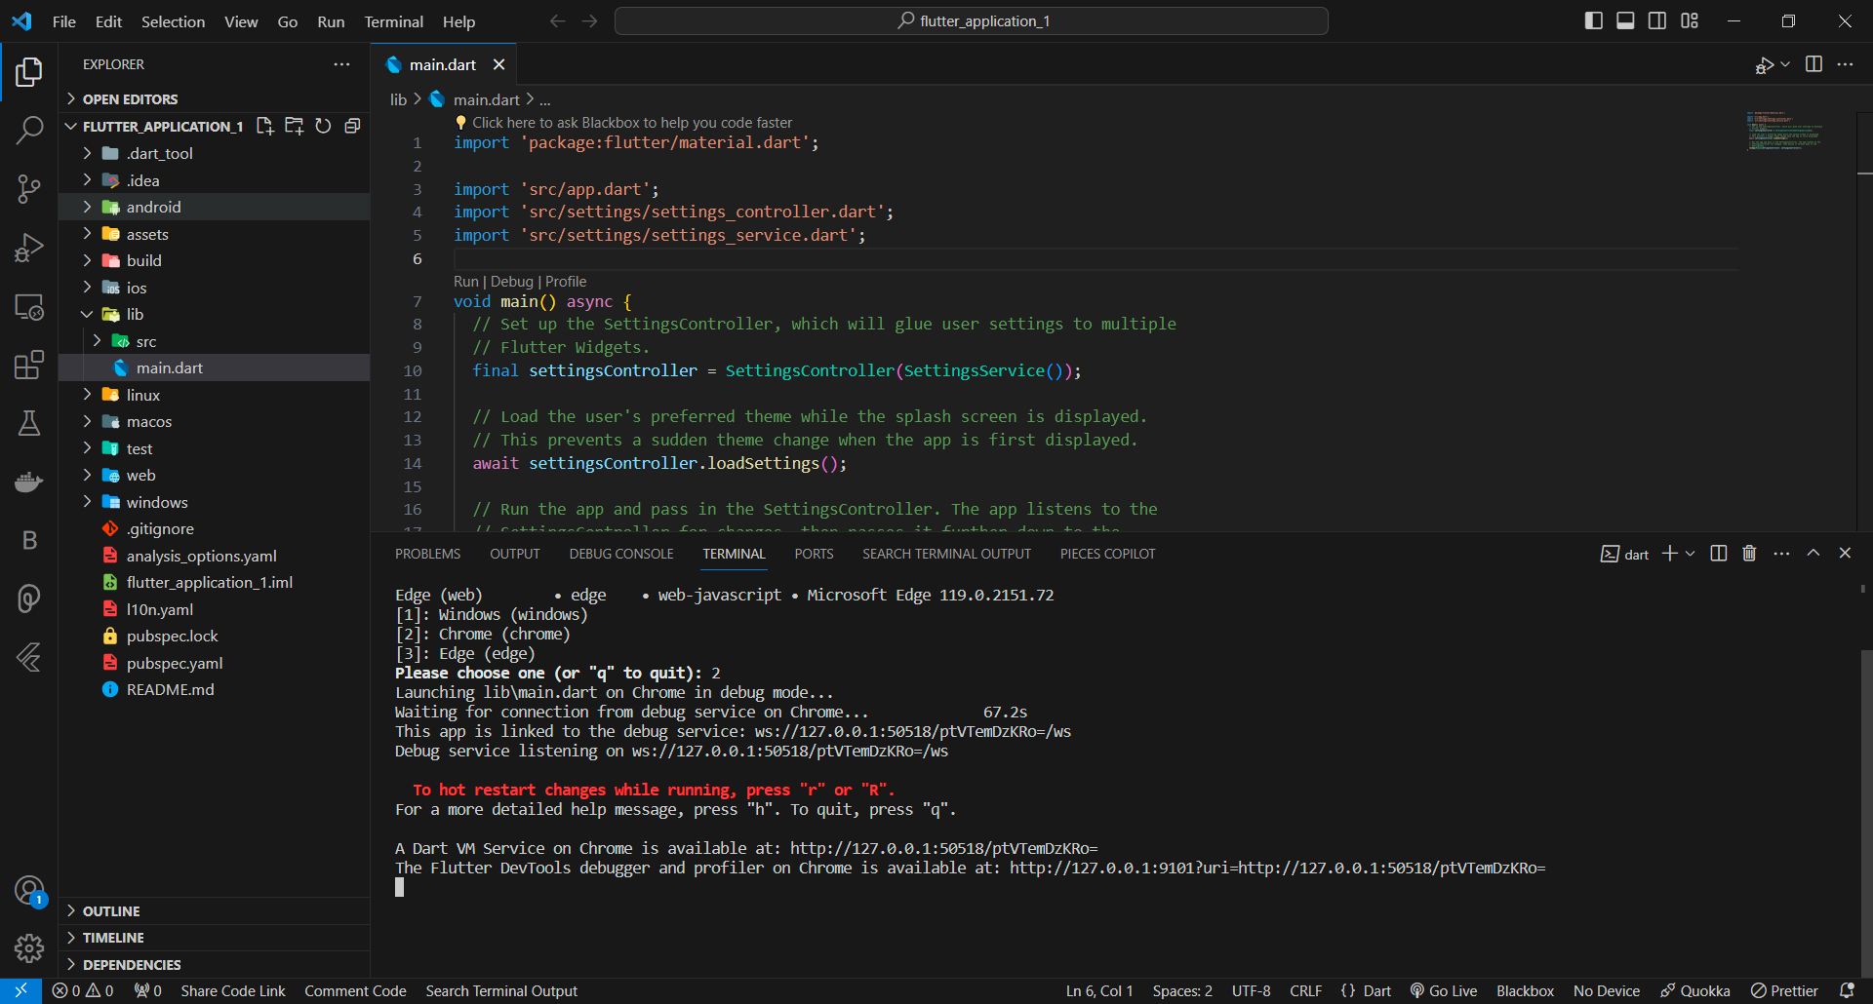

**Output:** Now we are ready to see the output, by default it has a program in which there is a button by clicking on the that a counter will be displayed in the center.

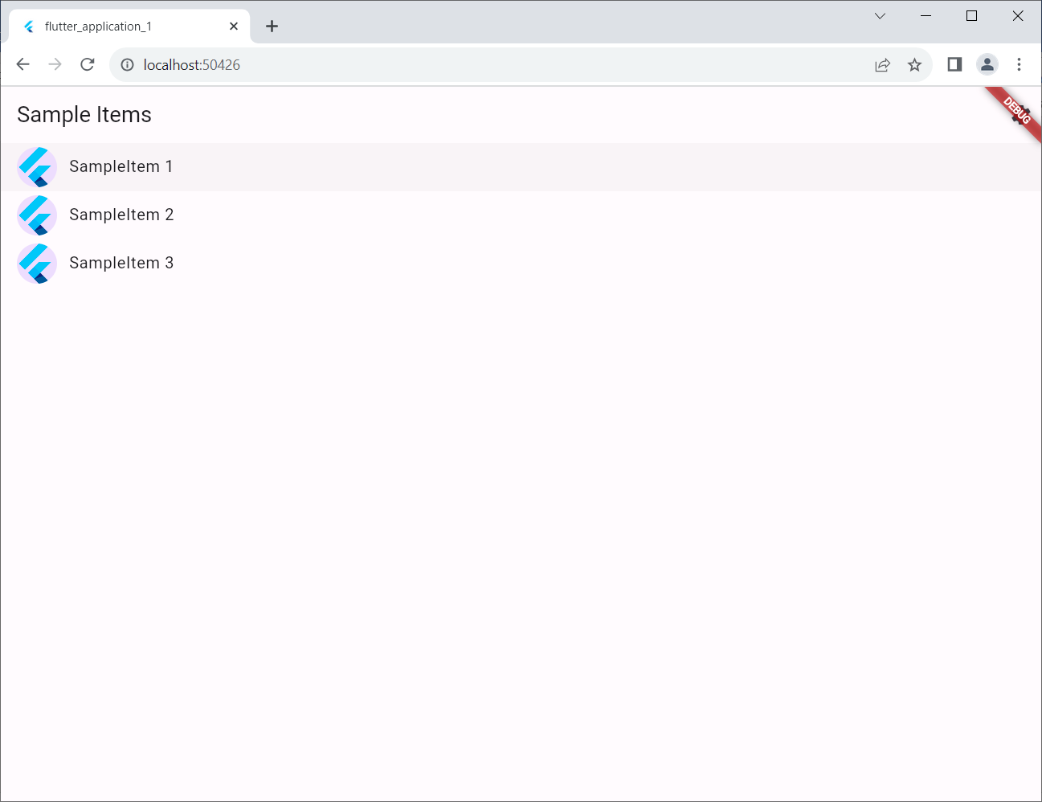

**Errors**

1. Intel HAXM is required to run this AVD. HAXM is not installed.

**Solution:**Watch this [video](https://www.youtube.com/watch?v=4hE8rE-vrjg).

1. The emulator process for avd pixel_xl_api_30 has terminated

**Solution:**

This error comes because of not enough space. First try to make some space where android avd placed. You have to free at least minimum 8GB.  
Secondly, if the error is not resolved watch this [video](https://www.youtube.com/watch?v=GdSWkVJ7GJU).